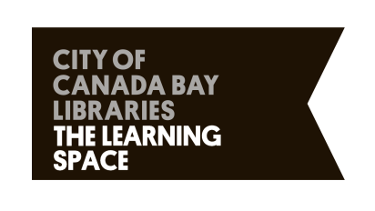
2021 Expressions of Interest for projects at the Digital Gallery,
The Learning Space

Application Form.

Artist/s name:

Contact phone:

Email:

Website:

Artist bio (150 words max.):
In a separate document, please also include an Artist CV – 1 page max.

Description of proposed artwork/s (350 words max.):
Include artwork medium & dimensions, and how the artwork relates to the themes detailed in the Artist Brief.
Please note that all works must be suitable for viewing by the general public.

Relationship to context (100 words max.):
How does the artwork engage with the community and/or context of Rhodes, within the City of Canada Bay more broadly (ie, interactive elements, relationship with community groups, local history etc)

Link/s to artwork sample or images:
If no links are available, please include a separate document with images – 10 images max.

Nominated artist fee, including brief cost plan:

Date the work is available for exhibition:

Would this work be ready to exhibit in May 2021? Yes | No

Do you hold current public liability insurance?

Thank you for your Expression of Interest.
- Please submit your application to vaughan.wozniakoconnor@canadabay.nsw.gov.au@canadabay.nsw.gov.au by

Sunday 21 February, 2021

