ARTIST
BRIEF

Exhibitions and Public Programs 2021

The Digital Gallery

The Learning Space, Rhodes

The City of Canada Bay is committed to providing high quality public art and exhibitions that support and enhance our cultural and community precincts, and our engagement with the people that visit them. As part of this commitment we are seeking artworks to be temporarily exhibited in The Digital Gallery within The Learning Space, Rhodes.

About The Learning Space
The Learning Space is operated by City of Canada Bay Library Services. It provides a vibrant and welcoming space which supports learning, creativity, innovation, and community. The Learning Space offers access to digital resources, places to study, work and gather, and a broad program of workshops and events in digital and creative making to support community learning at all levels.

About The Digital Gallery
The Digital Gallery is an exhibition space for media and interactive artworks. The space is 86sqm and forms the main entry to The Learning Space. It consists a digital monitor wall: 8 x 46inch LCD screens in a 4x2 formation, configured to display 2 x 16:9 images side by side. On the opposite wall is an AV presentation projection wall: two ceiling mounted data projectors and two large motorised screens. There is an integrated sound system, with hearing augmentation.
Wall mounted screens and projectors can be synced for multichannel video works, or played as individual channels with discrete audio inputs.
Located in the main entry to The Learning Space, the Digital Gallery is a high foot-traffic area, who visit the site to study, relax and meet socially.
The space is best suited to video and interactive works, incorporating additional wall or floor-based controls in consultation with Learning Space staff. There is an in-built glass display cabinet suitable for small scale artworks and objects. Wall-mounted artworks cannot be accommodated.

Artist Brief
Council is seeking artworks which will be curated into The Digital Gallery by The Learning Space team. The Learning Space is looking to program artworks for 2021.
Each artwork selected will be displayed for one exhibition period of up to six weeks.
Types of artworks can include (but are not limited to) video, photography, animation, VR, AR, sound, and sculpture. All artworks must be appropriate for general viewing.
The most effective works have engaged with the community, particularly through interactive elements and/or working with local resident groups. Given the risks of touch-based virus transmission from COVID-19, non-touch based interactive works are encouraged.
Online and/or internet-based works are also encouraged, to be developed in consultation with The Learning Space Staff.
Themes
We wish to engage work that addresses at least one of the following criteria:
- Exhibits exploratory or playful approaches to using digital media
- Broadens the creative possibilities relating to emerging or everyday technologies
- Promotes engagement or interaction with the local community and visitors using the space
- Involves languages other than English, or visual and non-language communication methods
- Engages a broad audience including children and people from non-English speaking backgrounds

We’d look favourably on work that can speak to the following themes in content or approach:
- Identity: personal and community
- Local history and place
- Global and cross-cultural connections
- Environment and landscape
- The impact of new technology
Artist Responsibilities
Council requires the artist to:
- Manage and deliver the artwork within the agreed production schedule
- Install artwork that exists and operates appropriately within The Digital Gallery and its existing infrastructure. This includes supplying digital artworks in the correct digital format and within specification. Plinths, stands, or equipment required for the work must be supplied by the artist and be approved by The Learning Space staff prior to installation
- Provide clear and detailed instructions for the daily operation of the artwork, including troubleshooting
- De-install artwork on the agreed upon date
- Hold a public liability insurance policy

Budget
Artists will be paid a once off fee per exhibited artwork. Artists are required to nominate their stage within the below schedule (based on NAVA Code of Practice 2017). This price is to include research and development of the work, delivery and installation and de-installation, and consultation with The Learning Space staff. A cost plan for these elements needs to be included in the expression of interest.

Stage | Fee
Emerging artist | $1,100
Mid-career artist | $1,300
Established | $1,800

Copyright
Copyright of the artwork is owned by the artist.
Wherever Council reproduces images and designs of artwork in electronic, print, or digital media the Council undertakes to acknowledge the project artist.
In the case of already existing work, the artist will ensure that appropriate copyright clearances are obtained for exhibition and promotion material.

Code of Conduct
The City of Canada Bay Council has adopted a Code of Conduct policy with the aim of ensuring that its functions are undertaken efficiently, impartially and with integrity. Council's Statement of Business Ethics is provided as supporting information.

Information required for application
To submit an expression of interest, please provide the following:
- Artist CV, including full contact details
- Artist bio (150 words max.)
- Artwork description and context statement (400 words max.), including
  - Medium and dimensions
  - Statement indicating how the artwork/s engage with the themes
- Images of artwork (10 max.), or links to view work online
- Nominate artist fee, including a brief cost plan
- Indicate the earliest date when the work is available
- Copy of current public liability insurance

Selection of Artwork
The successful applicants will receive written agreement upon their selection.

Application due Sunday February 21, 2021
All submissions and enquiries should be directed to:
Vaughan Wozniak-O’Connor
Technology Programs Officer
City of Canada Bay
E vaughan.wozniakoconnor@canadabay.nsw.gov.au
Specs and Floorplan

AV Control System:

AMX Controller playback devices:
1x Mac Mini
1x Windows playback
2x LUPA Media players

Digital Gallery Inputs:
XLR input
HDMI wall plate input
USB Input

Media Output:
Digital Video Wall (Left and Right Channels)
2x EPSON PA522U Projectors (16:10 Native Resolution)

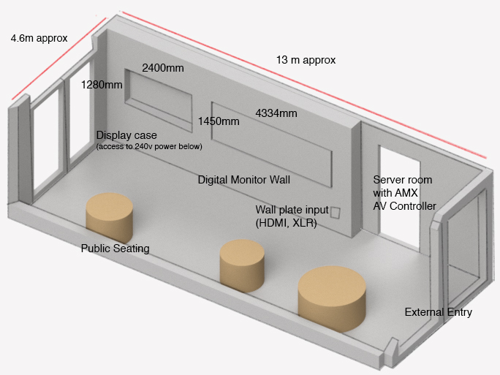
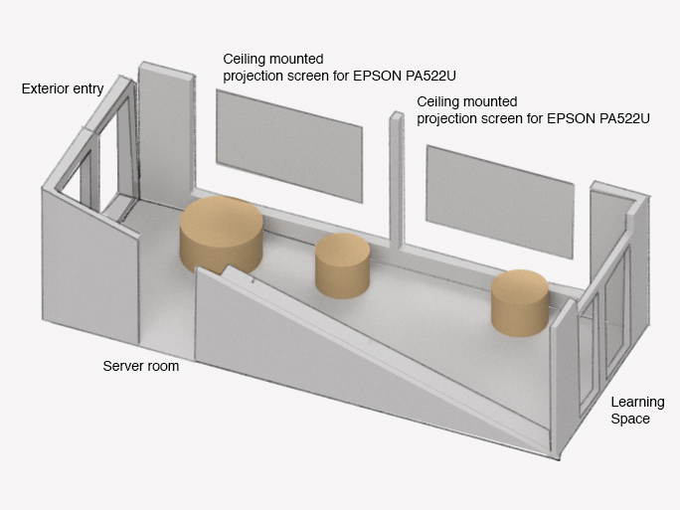
Floorplan:
1a Marlborough Street, Drummoyne NSW 2047
Tel 9911 6555 Fax 9911 6550 www.canadabay.nsw.gov.au

