1 October 2019

The Resident
DRUMMOYNE NSW 2047

Dear resident,

Landscaping and beautification works notification – Dunlop Reserve, Drummoyne

We have been progressing on the Dunlop Reserve Master Plan with the decommissioning of the old playground at Dunlop Reserve and completing the Stage Two seawall restoration works.

Continuing with the $370,000 upgrades identified in the master plan, I am pleased to announce we are ready to commence Stage Three which includes landscaping and beautification works

Works are scheduled to commence at the start of October and should be completed by the end of November, weather and site conditions permitting.

During the works, access to Dunlop Reserve will be restricted and we will endeavour to minimise disturbance and disruption to users of the reserve.

Should you require further information, please do not hesitate to contact our Senior Landscape Architect, Wendy Wright on 9911 6228.

Yours sincerely,

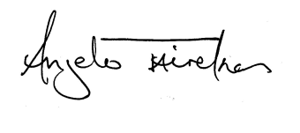

Mayor Angelo Tsirekas
City of Canada Bay

