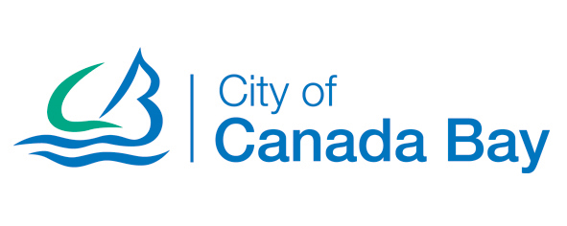

ROADS PROGRAM

Draft schedule of roads to be included in the 2019/20 road rehabilitation works:
Street | Segment Name | Suburb
Blackwall Point Road | Bibby Street to Riverview Street | Chiswick
First Avenue | Ingham Avenue to Park Road | Five Dock
Lavender Street | Queens Road to Parramatta Road | Five Dock

